**Ideation Phase**

**Define the Problem Statements**

|  |  |
| --- | --- |
| Date | 20 September 2022 |
| Team ID | PNT2022TMID54092 |
| Project Name | Gas leakage monitoring and alerting system for industries |
| Maximum Marks | 2 Marks |

**Customer Problem Statement:**

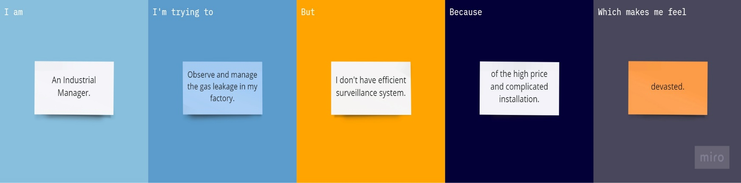

|  |  |  |  |  |  |
| --- | --- | --- | --- | --- | --- |
| **Problem Statement (PS)** | **I am (Customer)** | **I’m trying to** | **But** | **Because** | **Which makes me feel** |
| LPG is a highly is a flammable chemical which is used for cooking at home and certain industries. They have certain weakness that makes the gas leakage occur. Gas leakage can be detected by human nearby and if there is no human it cannot be detected. But sometimes it cannot be detected by human that has a low sense of smell. | A LPG factory manager. | Observe the gas leakage in the factory. | I don’t have any monitoring system. | The system price is high. | Worried. |
| Gas leakage leads to various accidents resulting in financial loss as well as injuries to human. In routine life, the environment has the most significant effect on human health. | An Industrial manager. | Control the gas leakage in my organization. | I don’t have an economical surveillance system.. | Of the harsh environment and positioning of the system is improper. | Distressed. |